Baffle Diffraction Step -- An Introduction
http://www.t-linespeakers.org/tech/bafflestep/intro-bds.html
David Dlugos
30-april-12
Baffle-step. A fact of physics.
What is Baffle-step diffraction?
There are a number of ways of dealing with this phenomenom:
1/ a huge baffle so that the BS is so low it doesn't matter. An approximation can be had by pushing the speakers closer to the wall... the smaller the actual baffle the closer you need to be to the wall.
2/ passive BS compensation between amp & speaker -- cored inductors outperform air-core inductors in most cases because you can dramatically decrease the series R in the inductor. Your problem is most likely the fancy inductor and not the Rs. Still this inserts some ugly reactive components where they have a chance to do their worst. A caveat with this technique is that itonly attempts to fix the on-axis baffle step FR level problems -- and unless your box is designed to have a very smooth baffle-step roll-off will never be able to do that
3/ passive line-level BS compensation -- recalc the LR for your amps input impedance -- here you could use really small single layer inductors -- we have a Paul Joppa article on how to do this
4/ active line-level BS compensation -- The same thing could be done with tubes, but it is an extra stage or two.
5/ The addition of a 0.5 bass speaker -- Set up a low pass filter for the lower woofer to coincide with the spreading loss of the upper woofer, net result is constant power output through the bass to midrange frequencies. Simple to do, all you have to do is run the upper woofer all the way down, while the lower woofer gets a 1st order rolloff. But it's best to do this with measurements, as for any of these techniques.
These are real tricky to get right, since as the bottom woofer rolls off its phase goes thru 90 degrees wrt the midbass that goes all the way up, so you get some phase disturbance in this region. Now if you put the 0.5 woofer on the back (see 6/) the phase rotation is in the shadow of the cabinet so is much less a problem... the cabinet also guarantees that the BS fill is perfect even if the XO is a little high.
6/ and my favorite approach -- what i call brute-force baffle-step compensation -- the bipole -- identical speakers on the front & the back. If you think about what happens when you hit baffle-step -- the sound is progressively wraping around the cabinet more & more as the frequency goes down. The same is happening with the back driver but facing the other way -- as the output of the front driver starts to fall off, it is exactly filled in by the bafflestep on the back driver -- this is true at the midpoint of the side of the speaker. Listening from the front the extra delay traveling to the front causes a dip. This can be minimized by making the baffle wider than it is deep. 3-4 to 1 eliminates most of the dip. You can also roll off the back speaker above bafflestep giving you a 1.5 way.
Fig 5.2 <http://www.t-linespeakers.org/projects/tlB/response.html> 1 driver vrs 2.
The compromise is that the speaker has to be out into the room more (not necessarily a bad thing) -- my room is excellent with a bipole. And of course the expense of that extra set of drivers -- the last actually cheap when you consider the 6dB power increase required for the same midrange levels if you use a filter.

Baffle Diffraction Step
Jason M. Neal
http://www.t-linespeakers.org/tech/bafflestep/index.html

An important loudspeaker design consideration is the baffle diffraction step, which is a result of the transition in the acoustical load presented to the loudspeaker. At high frequencies, a loudspeaker tends to project sound only in the forward direction that is, it has a 2 pi hemispherical radiation. At low frequencies, a loudspeaker undergoes a transition by which it begins to radiate sound in all directions, or a 4 pi spherical radiation. The result is an apparent reduction of bass response because the low frequency energy density is reduced in the forward direction where the listener is located. The overall effect is a gradual 6 dB shelving action at low frequencies, such that the bass is 6dB lower in level than the treble. See Figure 1 for a graph of baffle diffraction loss for an arbitrary 18" wide baffle.
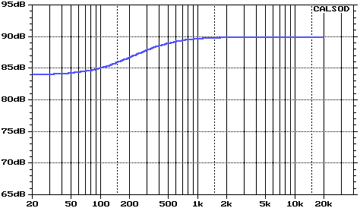
Figure 1. Effects of baffle diffraction for 18" wide baffle
Please note that this diffraction loss curve is for an ideal loudspeaker mounted in a sphere, which exhibits a very smooth transition. Other shapes, such as the common rectangular enclosure, will introduce peaks and dips in the response, but the overall trend remains the same. Very little may be done to predict these response anomalies as they are predominantly spurious. The only reliable way to determine whether these peaks and dips are objectionable is with listening tests and acoustic measurements.
Baffle diffraction loss is a function of wavelength. The wavelength (l) of a given frequency at room temperature and standard atmospheric pressure may be found by the following equation:
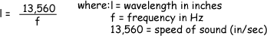
The baffle diffraction step may be most accurately described as a loss of bass, and not a gain in treble. However, if we view a graph of baffle diffraction, the amplitude "rises" as we move from left to right across the frequency axis. As an approximation, the rise begins at the frequency whose wavelength is 8 times the smallest dimension of the baffle. This dimension is typically the width of the loudspeaker since most are tall and narrow. Using the same 18" baffle as in the previous example, the response would begin to rise at [1/8 * (13560/18)], or 94 Hz. Also, the maximum amplitude is attained at a frequency whose wavelength is twice the smallest dimension of the baffle; in this case [2(13560/18)], or 1.5 kHz. The -3dB point has been empirically determined to be:
The f3 for our arbitrary baffle width of 18" would be 253 Hz. All these calculations are in agreement with the baffle diffraction loss simulation depicted in Figure 1. Based on the above equation, it becomes clear that diffraction loss begins at higher frequencies as the baffle width is decreased. Conversely, for an infinitely large baffle, there will be no loss whatsoever as the loudspeaker is radiating into a 2 pi environment at all frequencies. This effect may be approximated by mounting the loudspeaker within the plane of a large wall.
The baffle diffraction step is generally viewed as a problem since it results in a non-flat frequency response. However, a mirror-imaged shelving network may be implemented to correct the frequency response to a flat amplitude. All that is needed is a network that attenuates high frequencies at a rate of 6 dB/octave, and "topping out" at 6 dB's of overall attenuation. Dr. John Murphy has documented an approach for compensating for the baffle step, so it will not be repeated here.
I must say, however, that it is preferable to use an iterative process to develop a compensation circuit. This capability is offered by CALSOD and other such crossover optimization programs, after which the results should be verified with acoustic measurements. It is often possible to devise a compensation circuit that also incorporates filtering duties, rather than implementing a dedicated circuit. A dedicated circuit may introduce unnecessary series inductors into the circuit. These inductors are typically expensive, particularly if low DCR types are employed -- necessary to minimize performance degradation. Furthermore, inductor placement becomes more troublesome if mutual cross-coupling is to be avoided. However, those who do not possess sophisticated software/hardware will certainly find the dedicated circuit to be vastly superior to simply ignoring the phenomenon.
Most (but not all) loudspeaker manufacturers publish response curves taken in a 2 pi environment. Therefore, the effects of baffle diffraction loss are not depicted. Consequently, if the frequency response curve indicates flat response, there will be a reduction in the bass response when the driver is placed in an enclosure and into a room, a 4 pi environment. This is a very important concept to understand since it will affect the crossover design and also the maximum sensitivity attainable with the particular driver.
For example, suppose you have a woofer rated at 91dB/2.83V/1m and a tweeter also rated at 91dB/2.83V/1m. At first glance they would seem to be a perfect match for one another, at least in terms of sensitivity. However, baffle loss has not been factored in. In order to achieve flat amplitude response down to the low frequency limits of the driver, the midrange frequencies must be shelved down by 6dB, resulting in an 85dB sensitive woofer. This of course would also
necessitate padding down the tweeter to mate with the woofer. In reality, it isn't necessary to shelve down the entire 6dB if a somewhat premature rolloff in the upper bass is acceptable, whereby allowing for a higher average sensitivity throughout the midband. This decision is a purely subjective design choice that should ultimately be based on the specific circumstances and the listener's preferences. Many commercially designed loudspeakers opt for this extra sensitivity and typically choose a 3-4dB shelf. Here again, an iterative optimization program is useful for determining a crossover network which will provide this response.
No fancy ending to this story, but I do hope this information is somewhat helpful in explaining an esoteric and often misunderstood area of loudspeaker design. This information is an excerpt from an electrostatic loudspeaker paper I've written, and modified to cover a couple of issues not in the original copy. I know this overview is somewhat intimidating to a nontechnically-minded person, but I struggle for a way to simplify without also leaving out useful information. Good luck to all.

Baffle Step Compensation
by Alex Megann
Baffle Diffraction Theories and Practice
http://www.t-linespeakers.org/tech/bafflestep/bstepcompo.html
An assumption often stated is that the "baffle diffraction step" is a transition from radiation through 4pi solid angle (equal power at all angles) to a 2pi radiation pattern (power is only radiated to the front of the baffle). This is true for a speaker in an anechoic chamber or outdoors, and in these cases there will be a net 6 dB step (doubling of SPL) at high frequencies relative to the response at frequencies where the wavelength is large relative to the baffle size, with some ripples whose severity will depend on the shape of the baffle and on the driver position on the baffle.
In a real living room, though, the speaker will tend to be placed within a metre or two of the rear wall, and in any case low frequencies are not strongly absorbed at boundaries, so most of the rear wave will be reflected by the wall anyway. This means that the compensation theory described in John Murphy's article will give an excessive boost to the low frequencies (or a loss in higher frequencies), since the 6dB compensation doesn't match the loss, which will generally be less that 6dB.
When I first put my active crossover together I added a 6dB step compensation circuit, with centre frequency adjustable from 200Hz to 1200Hz. I eventually settled on around 450Hz, since according to John's analysis of Olson's results this corresponds to my baffle width of 25cm. Without the compensation the speakers sounded thin, but with it, even when I played with the centre frequency, they never sounded right - there was always too much energy in the upper bass or too little in the low bass.
I changed the resistors in the compensation circuit to get a 3 dB, rather than 6 dB, boost at low frequency, but with the 1.5dB point still at 450Hz. The change was quite striking - there is now more clarity and punch in the bass, and once I had changed the bass level I found the midrange had become more detailed.
The Problem -- to compensate for the power loss at low frequencies as the radiation pattern transitions from 2pi steradians to 4pi steradians. The frequency at which this occurs is a function of the baffle size.
The Circuit -- the following circuit can be used. It has unity gain at high frequencies and an adjustable gain at low frequencies:

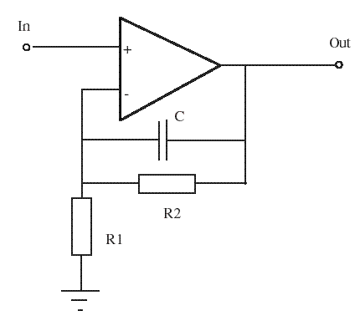
The response is
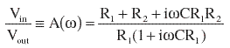
and the magnitude of the response is
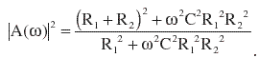
If we define the magnitude of the low-frequency limit as , we can calculate the ratio of the two resistors:
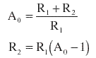
At some frequency w₀ let the desired response be A₁, which we choose to be some sensible value between unity and the DC limit A₀. I chose the geometric mean, equal to the square root of A₀, which gives the midpoint of the step on a decibel scale. Then we can calculate the values of both the resistors:
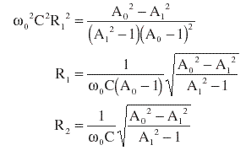
6dB Step
This is required to compensate for the diffraction loss of a speaker in free space.
If and then
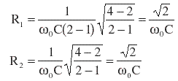
If C = 116 nF and w₀ = 2pi x 450 Hz (for a 25 cm baffle), R₁ = R₂ = 4311 W.
John Murphy suggests the following model response for the effect of diffraction for a baffle of width W_{b}:
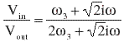
where 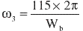(W_{b} in meters) is the frequency where there is 3 dB of boost relative to the full-space low-frequency limit. This is exactly compensated for by my circuit when A₀= 2 and w₃ = w₀.
3dB Step
In a real-life listening room, some of the diffracted sound will be reflected back towards the listener. In this case the loss will be less than 6 dB*. If we choose , and then
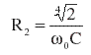
and
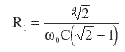
Using C = 116 nF and w₀=2pi x 450 Hz, R₁ = 8753 W and R₂ = 3626 W.
* John Murphy has some really good comments on this subject.
General parameter values
Since it is almost impossible to know exactly what fraction of the diffracted wave will find its way to the listening position, and since the effective baffle dimension is also hard to calculate (particularly for a truncated pyramid sitting on top of a rectangular box), it is useful to be able to experiment with different settings for f₀ and W_{b}.
I calculated component values for a switchable equaliser, with a choice of step frequencies and either five (1.5dB steps) or seven (1dB steps) low-frequency gains. These are based on a value for C of 100nF for a step centred at 1kHz, and are as follows:
  Step frequency
  Frequency | C
  300 Hz | 333.3 nF
  350 Hz | 285.7 nF
  400 Hz | 250.0 nF
  450 Hz | 222.2 nF
  500 Hz | 200.0 nF
  550 Hz | 181.8 nF
  600 Hz | 166.7 nF
  700 Hz | 142.9 nF
  850 Hz | 117.6 nF
  1 kHz | 100.0 nF
  Gain
  Gain | R₁ | R₂
  0 dB | 13,815 W | 0 W
  1 dB | 13,815 W | 1,686 W
  1.5 dB | 9,204 W | 1,735 W
  2 dB | 6,896 W | 1,786 W
  3 dB | 4,585 W | 1,892 W
  4 dB | 3,426 W | 2,004 W
  4.5 dB | 3,038 W | 2,062 W
  5 dB | 2,727 W | 2,122 W
  6 dB | 2,259 W | 2,248 W
References
Olson, H. F. "Direct Radiator Loudspeaker Enclosures", JAES Vol.17, No.1, 1969 October, pp.22-29
Visit Alex's web site.

Passive Line-Level Crossover
http://www.t-linespeakers.org/tech/filters/passiveHLxo.html
A passive line-level crossover (PLLXO) is a very good solution if you don't need circuits that are too complex circuits and can live with the insertion loss. You'll be rewarded with all advantages of biamping and you won't need opamps in
your signal path.
I'm currently using a 12 dB PLLXO for my satellites and I'm very satisfied.
6 dB filters would look like this, you can cascade them for higher orders, although beyond 2nd order the drawbacks become overwhelming.
First Order Lowpass:
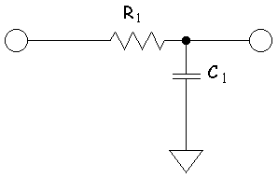 |  | Select a value for R₁ (around 5-10 k W should work well with most amps), then calculate the C's like this:  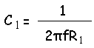  f = crossover frequency
First Order Highpass:
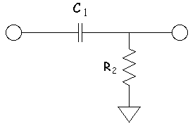 | 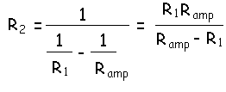  R_{amp} = the input impedance of the HP amp  If the input impedance is close to R₁ you need to consider it for the LP as well and raise the value of C₁.  Note: If R1 is left out, Ramp becomes the load R for the filer,
So for example, if we want a 60 Hz crossover point, and the total R is 10K, a 265.26 nF capacitor would be required.
You may also want to add a potentiometer for level matching.
The 12dB version looks much closer to a Linkwitz slope if it looks like this:
Second Order Lowpass:
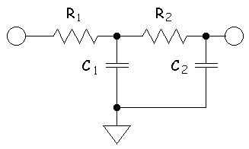 | Select a value for R₁, then:  f = crossover frequency  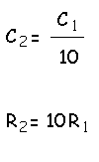  We must consider the R of the amplifier so:  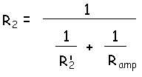  Solving for R₂':  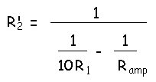
Second Order Highpass:
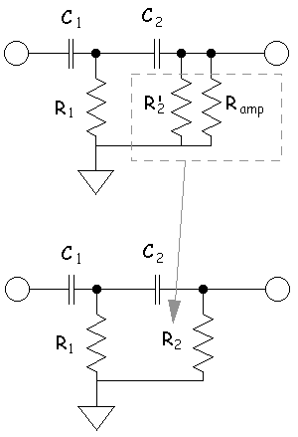
So for example, if f=1kHz: R₁=5 k W, R₂=50 k W, C₁=31.8nF, C₂=3.18nF
Note that the smaller resistor will more or less determine the impedance which your preamp will see, while the larger one is the main factor for the insertion loss, so things may get tricky if your amp has a low input impedance.
The amp's input impedance lies in parallel to C₂ and R₂.
In the hi-pass the input impedance of the amp is parallel to the capacitor C₂. If the input impedance gets lower, this has two consequences: the insertion loss gets higher and the xo frequency is shifted upwards. To compensate, calculate C₂ in the hi-pass as follows:
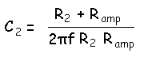
Note that the input impedance of your power amplifier needs to be fairly high to make a 2nd order hi-pass feasible. You can allways use the input impedance of your amp as the 2nd shunt R when calculating C₂, and just leave R₂ out.
A passive line-level crossover (PLLXO) is a very good solution if you don't need circuits that are too complex circuits and can live with the insertion loss. You'll be rewarded with all advantages of biamping and you won't need opamps in
your signal path.
I'm currently using a 12 dB PLLXO for my satellites and I'm very satisfied.
6 dB filters would look like this, you can cascade them for higher orders, although beyond 2nd order the drawbacks become overwhelming.

First Order Lowpass:
Select a value for R₁ (around 5-10 k W should work well with most amps), then calculate the C's like this:
f = crossover frequency
First Order Highpass:
R_{amp} = the input impedance of the HP amp
If the input impedance is close to R₁ you need to consider it for the LP as well and raise the value of C₁.
Note: If R1 is left out, Ramp becomes the load R for the filer,
So for example, if we want a 60 Hz crossover point, and the total R is 10K, a 265.26 nF capacitor would be required.
You may also want to add a potentiometer for level matching.
The 12dB version looks much closer to a Linkwitz slope if it looks like this:

Second Order Lowpass:
Select a value for R₁, then:
f = crossover frequency
We must consider the R of the amplifier so:
Solving for R₂':
Second Order Highpass:
So for example, if f=1kHz: R₁=5 k W, R₂=50 k W, C₁=31.8nF, C₂=3.18nF
Note that the smaller resistor will more or less determine the impedance which your preamp will see, while the larger one is the main factor for the insertion loss, so things may get tricky if your amp has a low input impedance.
The amp's input impedance lies in parallel to C₂ and R₂.
In the hi-pass the input impedance of the amp is parallel to the capacitor C₂. If the input impedance gets lower, this has two consequences: the insertion loss gets higher and the xo frequency is shifted upwards. To compensate, calculate C₂ in the hi-pass as follows:
Note that the input impedance of your power amplifier needs to be fairly high to make a 2nd order hi-pass feasible. You can allways use the input impedance of your amp as the 2nd shunt R when calculating C₂, and just leave R₂ out.

Loudspeaker Diffraction Loss
and Compensation

http://www.trueaudio.com/st_diff1.htm
by
John L. Murphy
Physicist/Audio Engineer

Loudspeaker enclosure "diffraction loss" occurs in the low frequency range of loudspeakers in enclosures that are located in the open, away from walls or other surfaces. The essence of it is this: At high frequencies the speaker is radiating into "half space" i.e. it is only radiating into the forward hemisphere. No significant energy is radiated to the rear of the speaker. At low frequencies the speaker is radiating into both the forward hemisphere and the rear hemisphere. That is, at low frequencies the speaker radiates into "full space". Because the "energy density" at low frequencies is reduced there is a loss of bass. In short, speaker systems designed for radiation into half space (mounted flush on an infinite plane) exhibit a loss of bass when implemented in typical speaker enclosures. Fortunately, this bass loss can be accurately modeled and subsequently compensated.
Most loudspeaker modeling is performed based on the assumption of radiation into half space. A speaker radiating into half space plays 6 dB louder than the same speaker radiating into full space. This is the crux of the diffraction loss. A full range speaker finds itself radiating into half space at the upper frequencies but radiating into full space at lower frequencies. As a result, there is a gradual shift of -6dB from the highs to the lows. This is what is called the "6 dB baffle step" or the enclosure’s "diffraction loss". The center frequency of the transition is dependent on the dimensions of the baffle. The smaller the baffle the higher the transition frequency.
The shape of the diffraction loss frequency response curve depends on the size and shape of the enclosure. Olson has carefully documented the diffraction loss of enclosures of various shapes (see references below). All enclosure shapes exhibit a basic 6 dB transition (or "step") in the response with the bass ending up 6 dB below the treble. A spherical enclosure exhibits this transition clearly with a very smooth diffraction loss curve. In the curves below I have taken the liberty of extending the frequency range of Olson's original graphs from 100 Hz to 20 Hz at the low end and from 4kHz to 5 kHz at the high end. The low frequency response was extended to more clearly reveal the "stepped" nature of the response. I wanted it to be clear that the response levels off at the low end. Olson's own reproductions of the measured diffraction loss of a sphere by Muller, Black, and Davis tend to confirm that my extensions to the responses are correct.
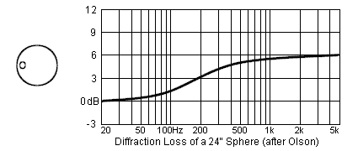
More "angular" enclosures exhibit the underlying 6 dB step along with a series of response ripples that are dependent on the placement of the speaker with respect to the baffle edges. The worst case appears to be placing the driver at the center of a circular baffle so that it is the same distance from all diffracting edges.
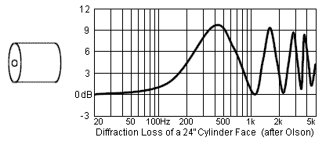

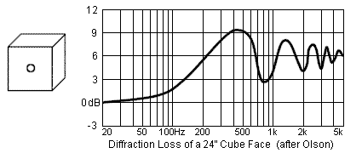
Placing the driver on the baffle so that it is a different distance from each edge tends to minimize the response ripples and make the diffraction loss look more like the smooth loss of the sphere. Olson's rectangular enclosure is an improvement over the cube and the cylinder face but the driver is still equidistant from three edges. Other authors report further reduction in the ripples with careful driver placement and edge rounding.
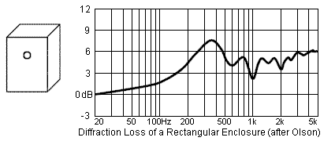
Because the spherical diffraction loss is a common element for the diffraction of all enclosures and the response ripples are much more difficult to predict (and can be minimized anyway) it makes sense to approximate the diffraction loss of a loudspeaker as the diffraction loss of the equivalent sphere.
One simple electrical circuit which produces a 6 dB step reduction in the bass response is shown below.
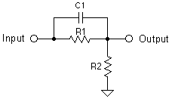
If we let R1 = R2 = R then a 6 dB attenuation results at low frequencies. At higher frequencies (where C1 becomes a low impedance) the attenuator is effectively bypassed and the signal is passed without attenuation.
It can be shown that the 3 dB "center" frequency for the above network is given by:
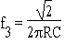
The frequency response of diffraction modeling network typically looks like this:
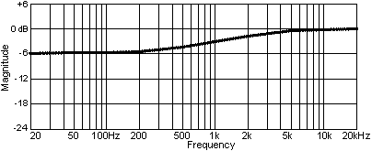
Careful inspection of Olson's spherical diffraction loss curve reveals a -3dB frequency of about 190 Hz for the 24" sphere. Assuming that the 3 dB frequency is inversely proportional to the baffle diameter I have arrived at the following approximation for calculating the -3dB frequency as a function of baffle diameter.
f(3) = 115/W(B)
(where W(B) is the baffle width in meters)
or
f(3) = 380/W(B)
(where W(B) is the baffle width in feet)
Sanity Check: for Olson's 24" (2 feet) baffle we calculate f(3) = 380/2 = 190 Hz . . .OK!
Once the diffraction loss is known it is possible to design a simple electrical network that will exactly mirror the spherical diffraction loss and restore the lost bass to a speaker system. Loudspeaker designers have traditionally compensated for the diffraction loss by reducing the level of the tweeter and making other adjustments in the crossover. The method I propose is to design for half space but then do a precise mirror image compensation for the diffraction loss by way of an R-L network wired in series with the (impedance compensated) speaker. Alternately, the diffraction loss can be compensated at line level with a simple R-R-C network. Line level correction would reduce the requirement for the large inductors typically needed for a speaker level compensation network.
A simple electrical network which produces a 6 dB step reduction in the treble response is shown below.
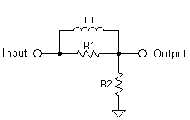
Here R2 represents the loudspeaker load impedance. If we let R1 = R2 = R then a 6 dB attenuation results at high frequencies. At lower frequencies (where L1 becomes a low impedance) the attenuator is effectively bypassed and the signal is passed to the driver (R2 here) without attenuation.
The frequency response of 6 dB diffraction compensation network looks like this:
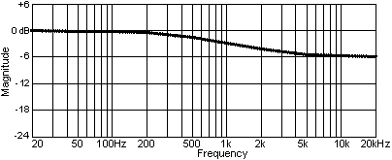
To design an RL network which will compensate for diffraction loss of a particular system we start by setting:
R1 = R2 = R =Nominal System Impedance (8 Ohms for example)
Next, you can use my empirically derived equation to calculate the value of the inductor L1:
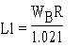
Where W(B) is the baffle width in meters, R is in Ohms, and L1 in millihenrys.
I arrived at this equation for L1 by forcing the 3 dB frequency of the compensating network to match the 3 dB frequency for the diffraction loss of the baffle.
The resulting RL network should be wired in series with the speaker system it is compensating. The correction will be most accurate if the loudspeaker itself approximates a resistive load.
Example:
Find the network required to compensate the spherical diffraction loss of a 4 Ohm speaker system with a 0.25 meter wide baffle.
R = 4 (the nominal impedance of the system)
(this resistor should have a power rating something like a quarter of the system power rating)
L1 = .25 x 4 / 1.021 = 1 / 1.021
L1 = .979 mH
(1 mH will be close enough)
To build this network, start by connecting a 4 Ohm resistor in parallel with a 1 mH inductor. Then connect this RL network in series with the speaker. You should hear reduced treble when the diffraction loss compensator is used.
WinSpeakerz models the diffraction loss of the enclosure as a simple spherical diffraction loss. Provided the driver is located "irregularly" on the baffle this gives very good approximation to the actual diffraction loss of the enclosure. The frequency of the transition is controlled by the "Baffle Width" parameter at the System Editor page 1. The response of the speaker can be viewed with or without the diffraction loss and the diffraction loss can also be viewed separately.
jlm
25Jun99 A follow-up post on this topic:
Question:
> I've been researching the idea of adding a baffle step compensation circuit
> to my Marchand XM9 active crossover. The only thing that seems hard to do
> is calculate the amount of boost actually needed as this is room dependent.
> The theory, see John Murphy's article at www.trueaudio.com, suggests 6db
> boost. An article at the TL web page suggests 3db is more likely with room
> reinforcement. Has anyone looked at this.
The 6 dB loss is correct for a speaker enclosure in free space. When the enclosure is placed in a room it will encounter various effects due to the room (reverb, standing waves, boundary effect, cavity effect . . .)
Diffraction loss and room effects are independent and completely different effects. The diffraction loss is nicely predictable whereas the effects of the room are highly variable, not only from room to room but also with speaker placement and room furnishing. This typically means that each listening environment will be unique and will require unique compensation.
I suggest the 6 dB diffraction loss correction as a correction for the diffraction loss alone. I don't suggest that it will neutralize all the effects due to a unique listening environment. Others suggest you "deal with diffraction" in the crossover, usually by just lowering the tweeter level a bit.
In some situations 3 or 4 dB of diffraction loss correction may result in an overall response that is closer to neutral (flat). But the most correct way to compensate the room would be to do it separately from any diffraction loss correction. Room compensation might take the form of several notch filters tuned to the worst peaks resulting from room modes. Next you might want to tilt the treble up a smidge to compensate for reverberation that has significant treble loss. Dark room reverb will make the playback sound a little darker. Bright reverb . . . bright. Next, depending on the size of the room and speaker response, you might need to compensate for the cavity effect. In larger rooms cavity effect can be ignored but in vehicle cabins it is a major effect.
Diffraction loss compensation is only part of the job of precisely compensating for the difference between a theoretical half-space acoustic load and what happens when we place an enclosure in a real world listening room. Reducing the degree of diffraction loss compensation MAY reduce the coloration from the room effects as these effects largely tend to "boost the bass" but such an adjustment is imprecise at best.
If we can systematically identify each source of color between our half space model and our particular listening room then we can then take steps to precisely neutralize the response in our own listening room. Spherical diffraction compensation is one effect we can correct with a high degree of precision. As we move toward a better understanding and modeling of our listening rooms I'm sure we will work out more practical and precise ways to compensate our rooms.
Comments and critique are welcome. :-)
Regards,
John
/////////////////////////////////////
John L. Murphy
Physicist/Audio Engineer
True Audio
http://www.trueaudio.com

Line Level Baffle Diffraction Step Compensation
Paul Joppa

Paul is a noted electronics designer and responsible for much of the Bottlehead line. This is derived from a post on the Full-Range Driver Forum
Written by Paul Joppa at 20 Apr 2004
A little while ago, Jon Ver Halen asked me to look into a line level equalizer that would provide the same equalization as the popular LR and LCR speaker level filters that are often used for single-driver speakers. Bass reflex and to some extent TQWT designs seem to be especially common applications. This started as a commercial project, but it turned out to be so simple that I thought it would be better to just put it in the public domain. Here is the result:
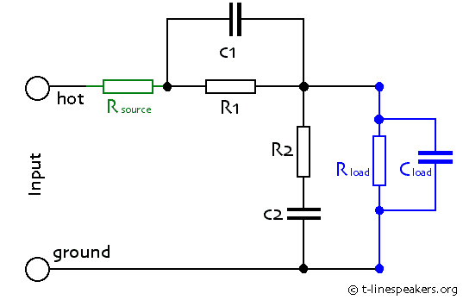
In the midband the gain is reduced to R₂/R₁+R₂, and is -6dB when R₁ = R₂. C₂ provides the low frequency boost by restoring the gain to unity at the lowest frequencies. C₁ is optional, and provides some treble boost (restores the gain to unity at the highest frequencies).
The LF time constants are R₂*C₂ and (R₁+R₂)*C₂. The HF time constants are R₁*C₁ and (R₁ || R₂)*C₁, where R₁ || R₂ means R₁ in parallel with R₂. Frequency is 1/(2*pi*time constant).
To make the calculations simpler, I assumed that the source impedance (R_{source}) is much lower than R₁ or R₂, the load impedance (R_{load}) is much higher than R₁ or R₂, and the capacitance of the load (C_{load}) is much smaller than C₁, which is itself much smaller than C₂.
In practice, as long as R_{source} is less than half of R₁ || R₂, and R_{load} is more than twice R₁ + R₂, the response will be within a dB of the predicted values. The greatest practical difficulty is with C_{load}. It must be less than 10% of C₁ in order for it to affect the performance by less than 1dB. Most of its effect is above the HF corner frequencies, so it might be reasonable to use a C_{load} as high as 20% of C₁. If C₁ is not used, then the only limitation is the (R₁ || R₂)*C_{load} time constant, which will cause a treble rolloff.
As an example, I determined parameters for two implementations (one active, one passive) to match Martin King's revised speaker level circuit, shown at:
http://www.quarter-wave.com/Project04/Project04.html
His speaker-level circuit has approximately 5.2dB midband cut, with low frequency corners at 220 and 400Hz and high frequency corners at 10kHz and 18kHz.
The active implementation assumes a tube gain stage to make up the 5dB loss, and a direct-coupled cathode follower so that C_{load} is very small and Rload is essentially infinite. Here are the values:
R_{source} = 15k
R₁ = 220k
C₁ = 68pF
R₂ = 270k
C₂ = 0.0015uF
C_{load} = 10pF
I compared this using the PSpice circuit simulation program to a model of King's circuit, assuming a constant 8 ohm speaker impedance (roughly what he measured, above 200Hz). The match is good, except this circuit is 1dB down at 20kHz due to the 10pF input capacitance of the cathode follower.
For a passive implementation between preamp and power amp, the C_{load} would be larger. Most tube amps have around 100pF input capacitance, and the cable will have more. A frequently used number is 1000pF for long cables, but with short cables of 3 feet or less, a C_{load} of 200pF might be achievable. Then you could use the following values:
R_{source} < 2k ohm
R₁ = 10k
C₁ = 1500pF
R₂ = 12k
C₂ = 0.033uF
R_{load} > 50k
C_{load} = 200pF
A minimum load of 12k is presented to the source, which is on the low side but achievable with most gear; in the midband the load is 22k.
For experimenters, a useful modification would be make R₁ a variable resistance, or replace both R₁ and R₂ with a linear taper potentiometer. This way the magnitude of the boost can be adjusted, to compensate for room acoustics for instance.
I hope this is useful to the community.
(Rod Elliot's simpilar scheme) – далее:

Baffle Step Compensation

http://sound.westhost.com/bafflestep.htm
Introduction
The so called "baffle step" is an increase in output from a loudspeaker as the size of the baffle becomes significant in terms of the wavelength of sound for a range of frequencies. At low frequencies, where the baffle (the panel the loudspeaker is mounted on) is small compared to the wavelength, the speaker is assumed to be operating with a spherical radiation pattern. While this may be the case should the speaker be situated up a tree in the middle of a field, it hardly qualifies as true when the same loudspeaker is installed in your listening room. There may of course be something about you that I don't know (for example that your speakers really are up in trees), but for the majority this will not be the case.
As frequency increases, the size of the baffle becomes significant, and the spherical radiation pattern no longer applies. This is also partly to do with the loudspeaker drivers themselves - as frequency increases, typical cone drivers become more and more directional anyway - this occurs as the dimensions of the cone become significant with respect to wavelength.

Baffle Step Response
It has been shown by Olson et. al. that the optimum enclosure for a loudspeaker driver is a sphere - that is to say that there is no "baffle" as such, but that the driver is installed in a spherical enclosure. While this is all very well in theory, spheres are hard to build, and even harder to include in a typical lounge room unobtrusively.
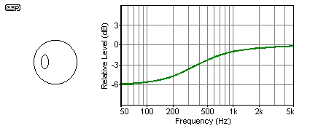
Figure 1 - Response Behaviour - 300 mm Sphere (After Olson)
The increase in output can be seen as the dimensions of the sphere approach the wavelength of the reproduced frequency. Once the wavelength is smaller than the diameter of the sphere, the response flattens out again, having risen by 6dB from the low frequency level. The radiating efficiency of the driver starts to increase earlier than one might imagine - there is a 1dB increase in SPL at the frequency where the baffle is about 0.2 of a wavelength, and the baffle step effect has no influence when the baffle width is greater than 3 wavelengths. At this point, the driver is effectively radiating into a hemisphere.
The absolute worst enclosure is a circular tube (cylinder), with the driver mounted in the exact centre of an end-cap. The response ripples caused by this are extreme, but with most systems this is not an issue, since this would be a very unusual shape for an enclosure. The response in a cylinder shows fluctuations in level that are quite unacceptable, and it is not a shape I would recommend to anyone. A cube is little better, and again the effect is made very much worse if the driver is mounted in the centre. Bacause these shapes are (or should be) avoided altogether, I have not included any response graphs.
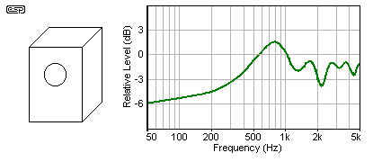
Figure 2 - Response Behaviour - 300mm Wide Rectangular Box (After Olson)
The overall behaviour is greatly improved with any mounting method if you ensure that the centre of the driver is a different distance from each edge of the box. These distances should be "non-harmonic", which is to say that they should be different, but in such a way that no one distance is an even multiple of any other.
When the distances from the driver centre to three sides are equal, the response will be much like that shown in Figure 2. This is better than a cube or cylinder, but much greater improvements can be made, just by changing the position of the driver. In addition, rounded edges will cause less refraction than square or raised edges, further improving the overall response, and particularly at the higher frequencies.

Baffle Step Equalisation
The baffle step is easily compensated for where the speakers are mounted in trees or are in other (more sensible) outdoor environments, but becomes much more difficult as a normal listening room is introduced. Adjacent walls, cabinets and other furnishings will all have an effect, and the outcome is unpredictable at best.
It has been determined that the baffle step may only be a couple of decibels in some circumstances, and sometimes less. In a normal room, it is unlikely that the step will be greater than 3dB, unless the speakers are a considerable distance from the walls.
To this end, I have determined a simple passive network that allows you to adjust the level with a pot, until the response is optimum. The frequency is fixed, and is easily determined based on the width of the baffle. The equaliser circuit should be placed between the preamp and power amp - it is not suitable for use in the speaker lines. Although circuits exist for use in the speaker lines, I would not recommend them in any situation, since power losses are very high, and they cannot be adjusted easily to suit your listening environment.
Based on an excellent formula developed by John Murphy (True Audio), we can calculate the frequency easily for the box ...
 | f₃ = 115 / W_{B} | (where W_{B} is the baffle width in meters)
 | f₃ = 380 / W_{B} | (where W_{B} is the baffle width in feet)
Needless to say, I will use metres, and as shown in the graphs above, will use a baffle 300 mm wide. The frequency is therefore ...
f₃ = 115 / 0.3 = 383 Hz

Variable Equaliser
A circuit is needed that will provide a typical 3dB decrease in level at the calculated frequency, and the (very simple) schematic is shown in Figure 3.
The value of C1 is determined by the following (1/2 of the pot value is added to the resistor value, since both are in series, and a typical situation will have a pot setting of around halfway - there will always be some error, but it will normally be quite small in practice) ...
C1 = 1 / ( 2 * π * ( R1 + VR1 / 2 ) * f )
C1 = 1 / ( 2 * π * 15k * 383 ) = 27nF
Since the formula will regularly give values that are not obtainable, we may use the closest available value with little error. Certainly the error will be very much smaller than that created by the room acoustics and other influences. The sample circuit is shown in Figure 3, and as shown is valid for a box with a 300mm wide baffle. The only change that you will need is to the value of C1 according to the above formula.
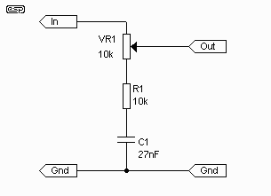
Figure 3 - The Baffle Step Correction Circuit
It is essential that the compensation circuit be driven from a low impedance source, and the load impedance should be reasonably high. There will be little error with loading above 20k, but basically the higher the impedance, the better. Opamp buffers at the input and output may be used if you cannot ensure that the source impedance is 100 ohms or less, and that the load impedance of the following stage is greater than 20k. My recommendation would be to use a buffer stage at the output with an input impedance of about 100k.
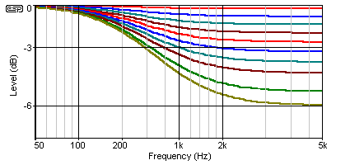
Figure 4 - Typical Frequency Response at 10% Increments
As shown in Figure 4, the pot may be moved from a flat response right through to full 6dB compensation. The graph shows 10% increments of the pot. When the pot wiper is at the top of its travel (based on the schematic), the circuit is inactive, and maximum compensation occurs at at the opposite end of the pot's travel. Nearly all normal listening room environments will use a setting somewhere in between.

