YXY-CY009产品说明书
Возможно, процессор - ats2805

8-24v 支持DTS AC3 高低音调节 3寸液晶屏 MP4 MP5音频、视频解码板

8-24v supports DTS AC3 high bass tune 3 inch LCD screen MP4 MP5 audio and video decode board.
修改

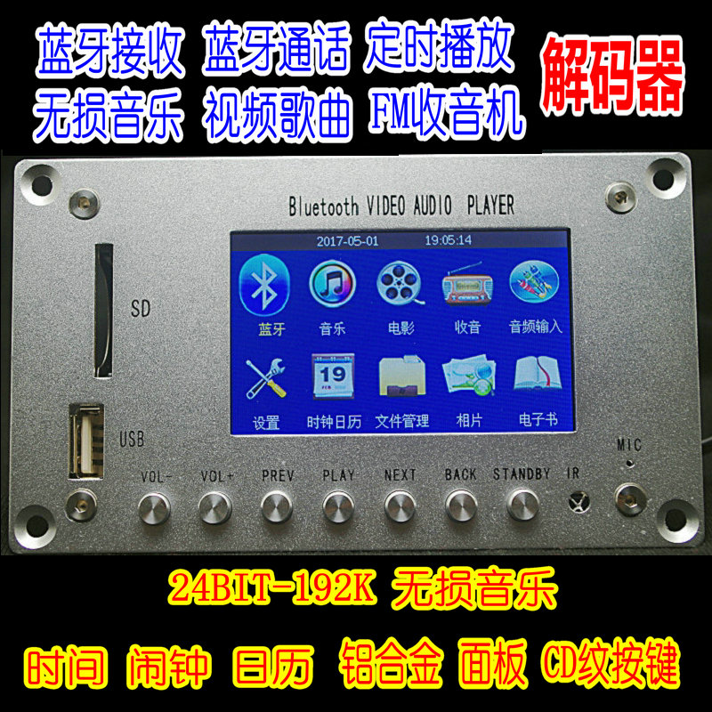

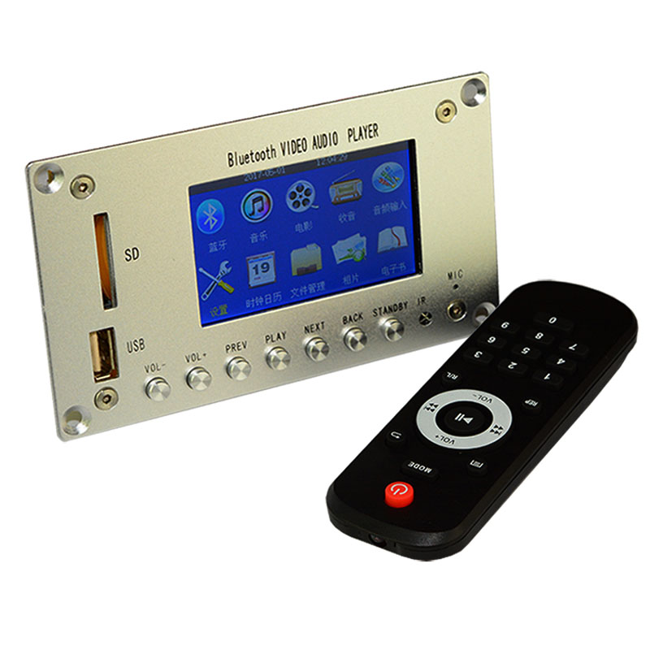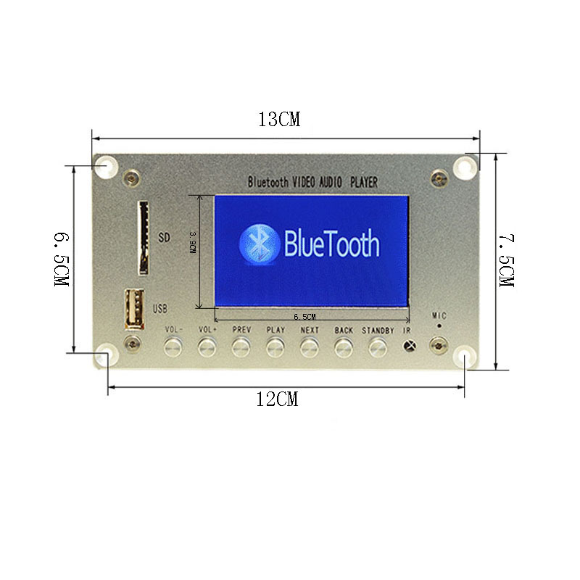
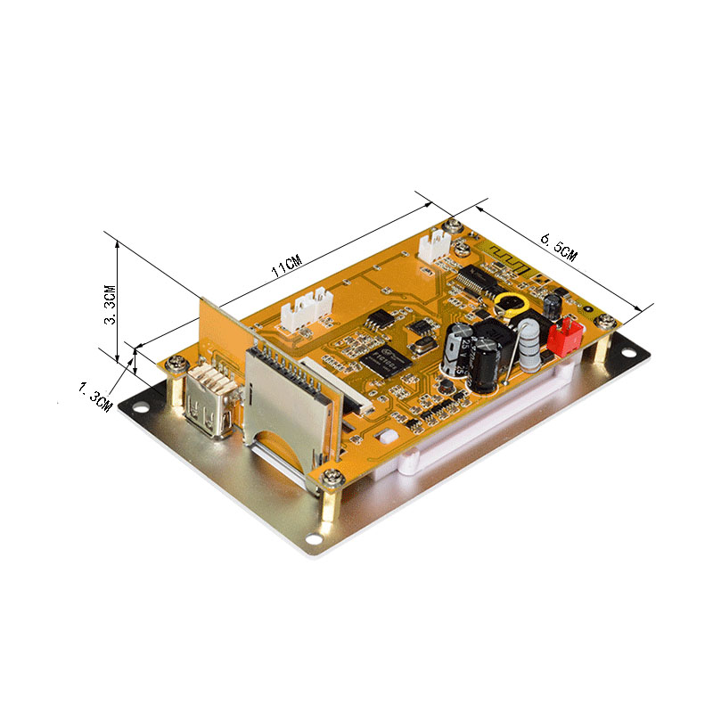
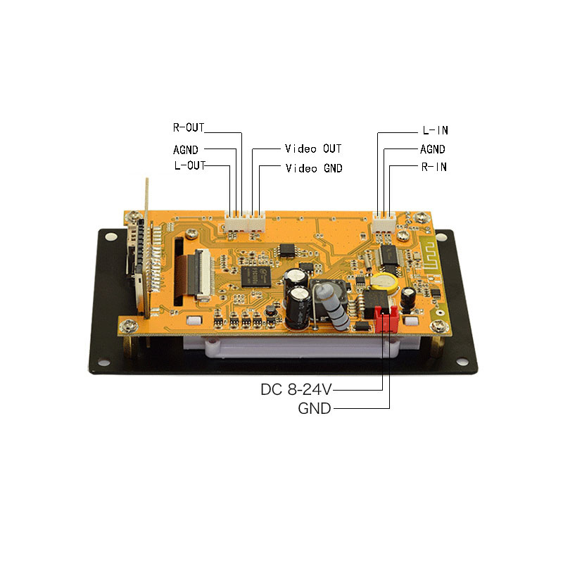

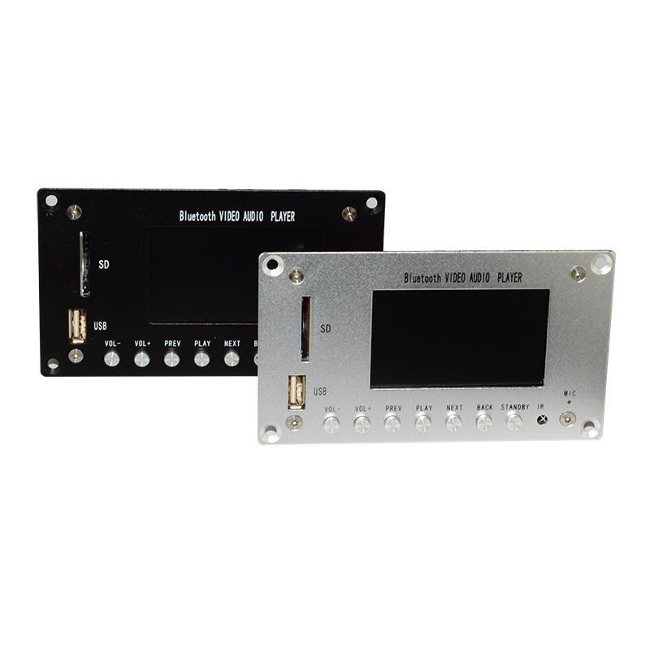
黑色 银色
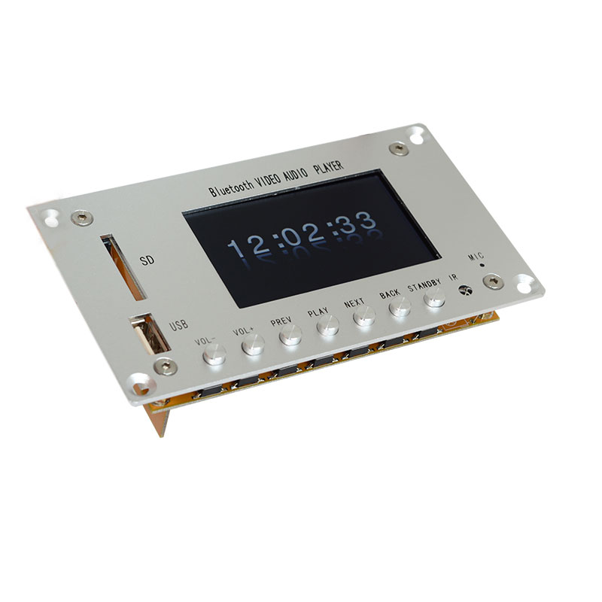
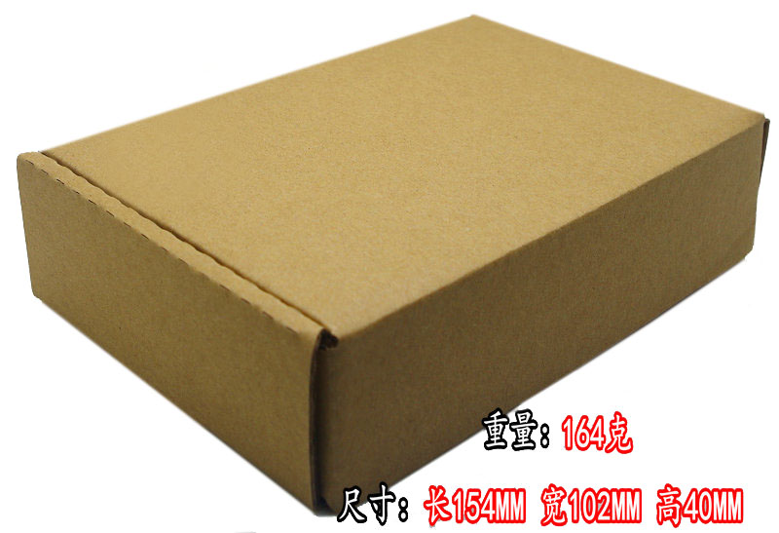
功能简介
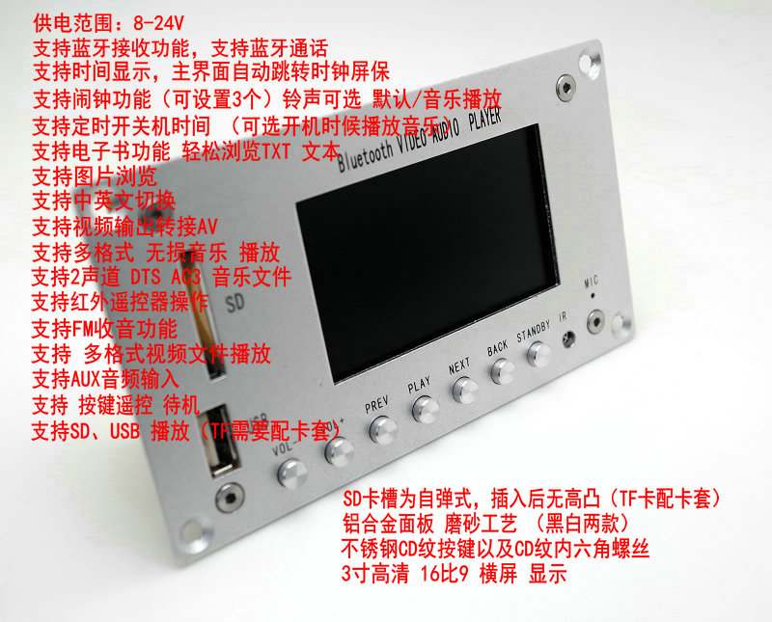

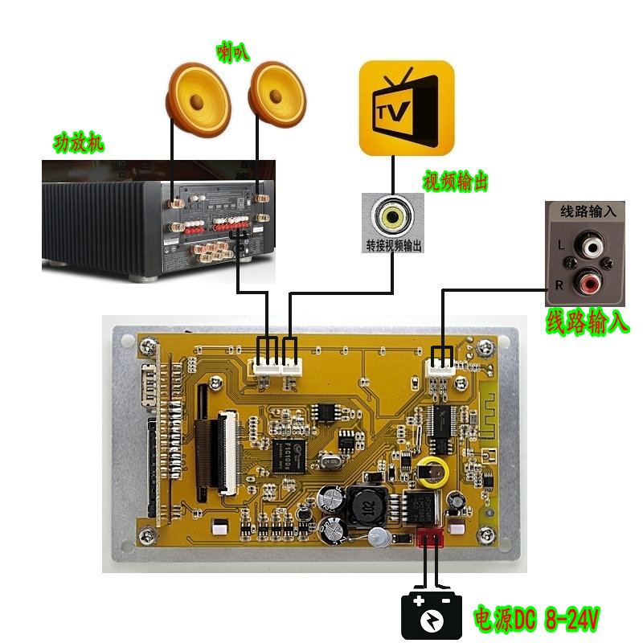
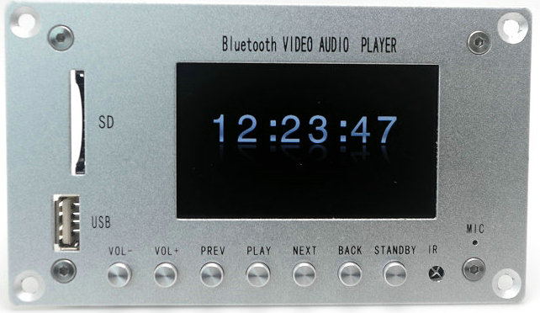

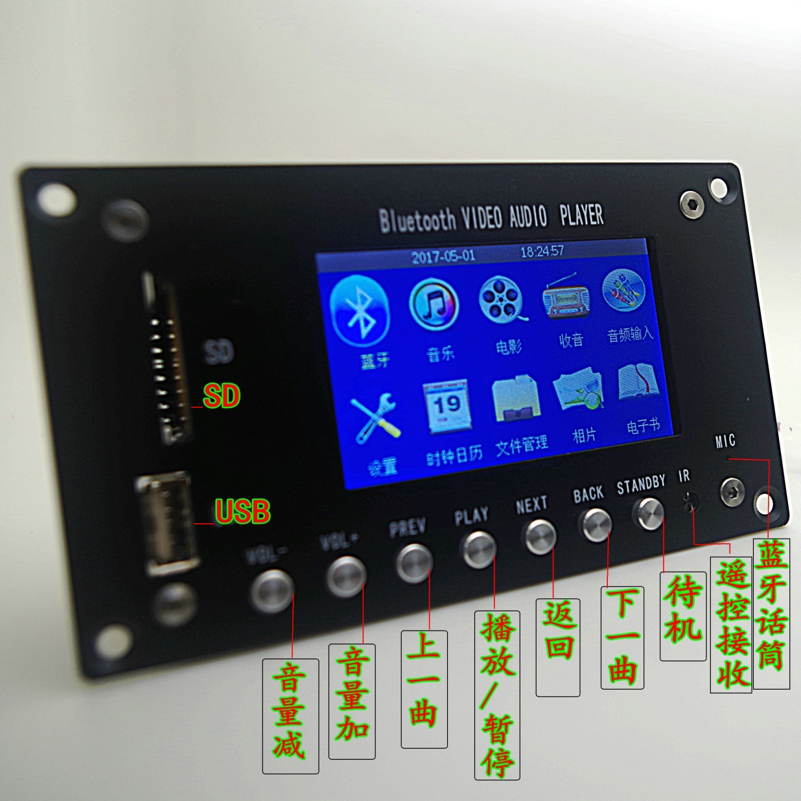
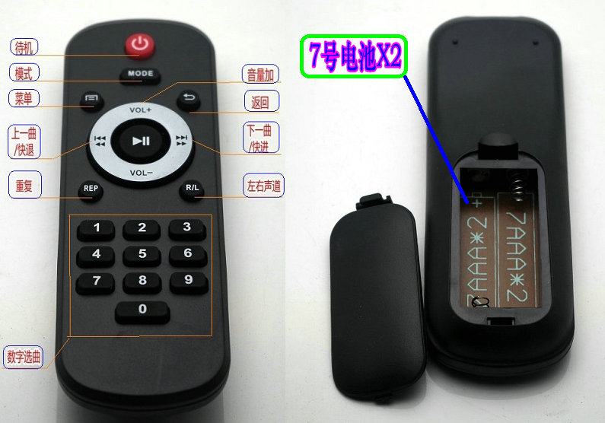
中文/英文显示切换
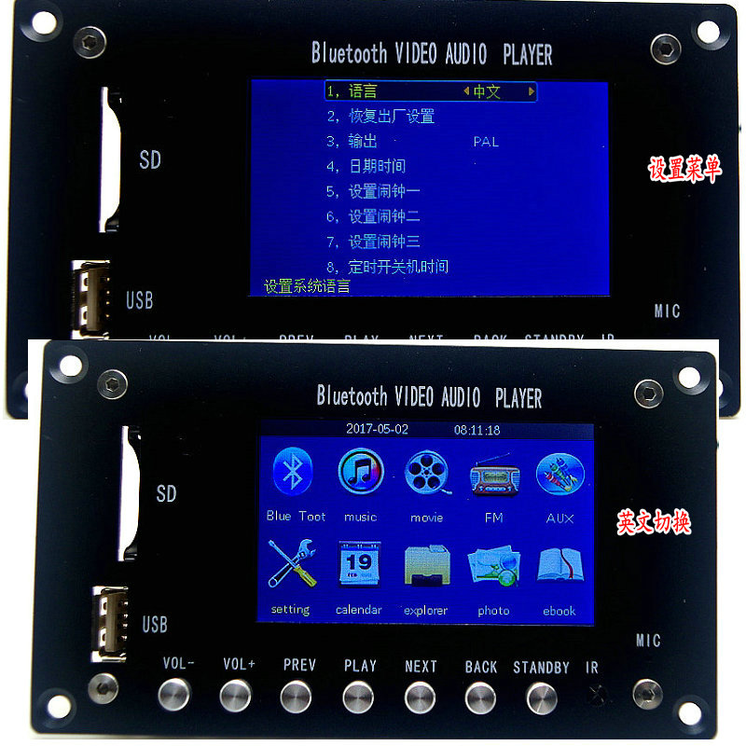
音乐/MTV视频 播放
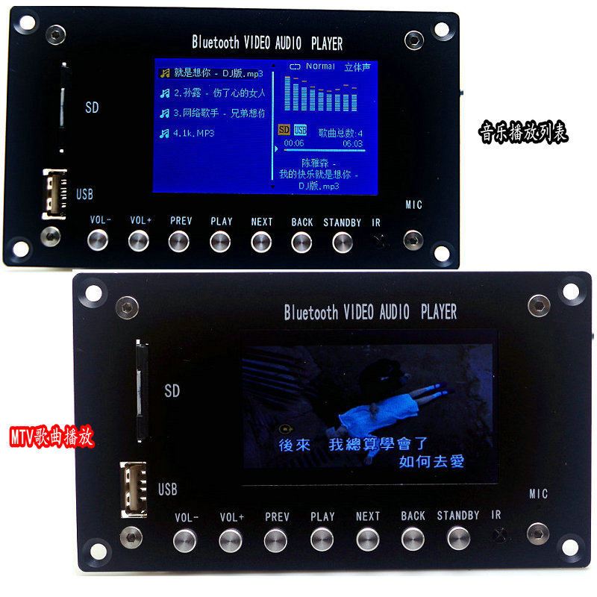

收音/蓝牙播放
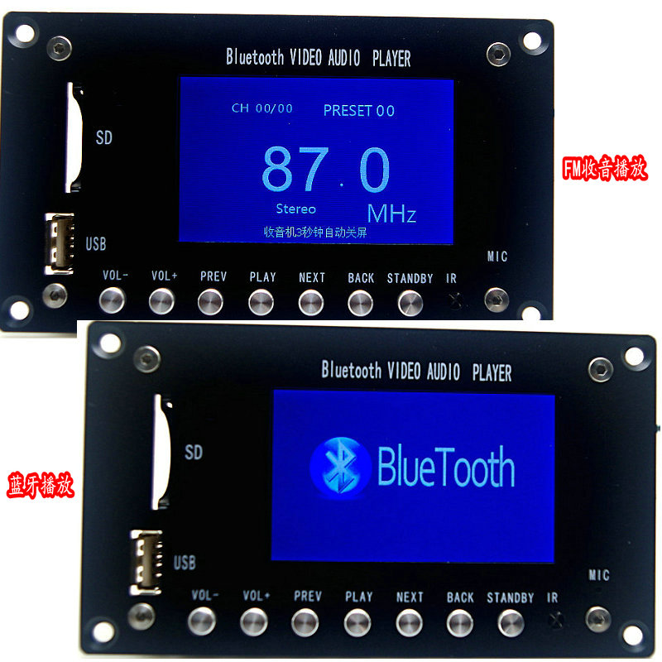
线路输入时钟显示
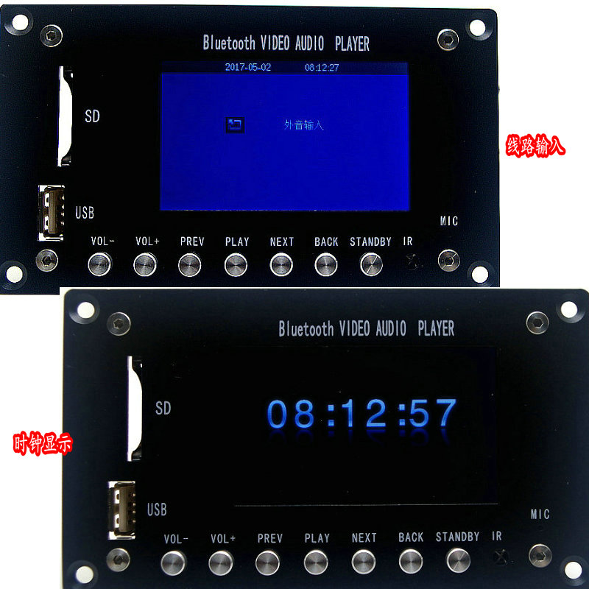

功能特点：

- 12V-24V直流电源(笔记本电源，适配器，开关电源，（线性变压器需要整理滤波为直流）)
- 支持多种编码格式MPEG-1,MPEG-2,MPEG-4 ,H264 XVID视频解码最高可达1280*720. 内置2声道输出.
- 支持蓝牙接收功能：蓝牙版本4.2
- 支持蓝牙通话
- 支持时间显示
- 支持闹钟功能（可设置3个）铃声可选 默认/音乐播放
- 支持定时开关机时间 （可选开机时候播放音乐）
- 支持一路AUX 线路输入
- 动态设置功能， 数码相册流畅播放、
- 电脑下拉式菜单设置，操作更方便、舒适；
- 超强兼容RM，RMVB，DVD、SVCD、VCD、DVCD、DVIX、FLV , MKV,AVI、MP3等标准格式，流畅解读MP3、 WMA、OGG、FLAC、ACC、APE；
- 支持电子书功能 轻松浏览TXT 文本
- 多种语言支持(默认中文、英语、其他语言根据需要可添加)、
- 视频输出支持：CVBS（通过视频模式菜单选项的TV-OUT实现，视频输出）
- 液晶屏： 3寸液晶屏显示
- 方便快捷红外遥控操作，
- 支持高清视频分辨率（1280*720）
- 支持RM/RMVB格式的分辨率为（1280*720）
- 支持图片格式： JPEG，BMP，柯达PICTURE，CDG；
- 播放视频格式：RM，RMVB，DVD、SVCD、VCD、DVCD、DVIX， MPEG4 ,AVI，VOB等；
- 播放音频格式：MP3,WMA,HDCD；OGG、FLAC、ACC、APE
- 软件智能升级

12V-24V DC power supply (notebook power, adapter, switching power supply, (linear transformer needs to be filtered for DC).
Support a variety of coding formats MPEG-1, MPEG-2, MPEG-4, H264 XVID video decoding up to 1280*720. built in 2 channel output.
Bluetooth reception: Bluetooth version 4.2
Support Bluetooth calls
Support soprano, bass, total volume regulation
Support time display
Support alarm clock function (Set 3) ringtone optional default / music playback.
Support time to turn on and off time.
Support the AUX line input
Dynamic setting function, digital album smooth play,
The computer pull-down menu settings are more convenient and comfortable to operate.
Super compatible RM, RMVB, DVD, SVCD, VCD, DVCD, DVIX, FLV, MKV, AVI, MP3 and other standard formats, fluent interpretation of MP3, WMA, OGG, FLAC, ACC, APE;
Support e-book functionality to easily browse TXT text
Multi lingual support (default Chinese, English, other languages can be added as needed).
Video output support: CVBS (through video mode menu option TV-OUT implementation, video output)
LCD screen: 3 inch LCD screen display
Convenient and fast infrared remote control operation,
Supporting high definition video resolution (1280*720)
The resolution of supporting RM/RMVB format is (1280*720).
Support picture format: JPEG, BMP, Kodak PICTURE, CDG;
Video format: RM, RMVB, DVD, SVCD, VCD, DVCD, DVIX, MPEG4, AVI, VOB, etc.
Broadcast audio format: MP3, WMA, HDCD; OGG, FLAC, ACC, APE
Software intelligent upgrade

